

**DEPARTMENT OF**

**ELECTRONICS AND COMMUNICATION ENGINEERING**

**College of Engineering and Technology, SRMIST**

MINI PROJECT REPORT

EVEN Semester, 2021-22

Sub. Code & Name : 18ECC202J-Linear Integrated Circuits

Year & Semester : II Year, IV sem

Project Title :

Supervisor :

Team Members :

|  |  |  |  |
| --- | --- | --- | --- |
| Reg. No | RA1911004010XXX  Name | RA1911004010 | RA1911004010 |
| Mark split up |
| Novelty in the project work  (1 marks) |  |  |  |
| Level of understanding of the design formula(2 marks) |  |  |  |
| Contribution to the project  (1 Marks) |  |  |  |
| Report writing (1 Marks) |  |  |  |
| **Total (5 Marks)** |  |  |  |

Date:

**Signature of Supervisor**

**BATHROOM LIGHT TIMER**

**OBJECTIVE:**

The automatic bathroom light off timer is built around IC 555 timer which will turn off the light after a preset time of 1 minute when there is no one in the bathroom.

**ABSTRACT:**

The automatic bathroom light off timer is built around IC 555 timer which will turn off the light after a preset time.

The main advantages of this circuit are when there is no one in the bathroom it will automatically switch off the light after preset time, thus saving electricity. Once timer switches off it will not reset automatically until we supply power. Consume no current in standby mode therefore longer battery life. Provide facility to set time according to the requirement. It can be easily mounted.

**INTRODUCTION:**

Give a brief description of the application addressed in the project.

**HARDWARE REQUIREMENT/DESCRIPTION:**

IC555, Relay (5 Pin), LED, Diode, Capacitor,etc

Give the description

**CIRCUIT/COMPONENT SPECIFICATIONS:**

|  |  |
| --- | --- |
| Supply voltage (*V*CC) | 4.5 to 15 V |
| Supply current (*V*CC = +5 V) | 3 to 6 mA |
| Output current (maximum) | 200 mA |
| Power consumption (minimum operating) | 30 mW@5V |
| [Operating temperature](http://en.wikipedia.org/wiki/Operating_temperature) | 0 to 70 °C |

**CIRCUIT DIAGRAM:**

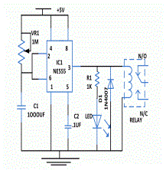

**DESIGN FORMULA:**

In this circuit 555 timer is wired as one shot timer whose timer period can be easily calculated by the formula,

**T=1.1*R1*C1**

**=1.1*1000*1000*1000µf**

**=1.1**

where T is in seconds, R is in ohms and C is in farads.

**DESIGN ISSUES:**

* Maximum supply voltage should not exceed 15V
* Humidity should not exceed 85% relative humidity.
* Timing tolerance should not exceed +10 sec for 1 min.

**APPROACH/METHODOLOGY:**

When anybody wants to use the bathroom, he will press the switch momentarily. As soon as switch is pressed, relay connected to pin 3 of IC1 gets energized and switches "on" the light connected to the relay. After the preset time, the output of timer will go low and de energizes the relay, thus switching "off" the load connected to the relay. In this circuit you can adjust the time with the help of VR1 and calculate the time period from the above formula.

One must take care of specification of relay before mounting like how much load current it will support. It is always suggested to keep the relay coil current within 200mA. If you want to exceed the coil current one must use driver transistor to drive the relay

**CONCLUSIONS:**

Thus the Bathroom Light Timer Circuit is constructed and the LED turns OFF automatically after the Preset Time thereby saving electricity

**REFERENCES:**

www.engineersgarage.com/electronic-circuits/bathroom-light-timer

**APPENDIX:**

**IC 555 :**

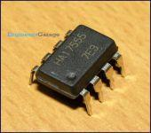

IC 555 is a very commonly used IC for generating accurate timing pulses. It is an 8pin timer IC and has mainly two modes of operation: monostable and astable. In monostable mode time delay of the pulses can be precisely controlled by an external resistor and a capacitor.

**RELAY ( 5 PIN ) :**

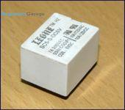

Relay is an electromagnetic device which is used to isolate two circuits electrically and connect them magnetically.

**LED :**

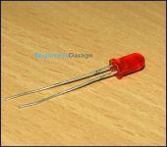

LEDs are Light Emitting Diodes. They are super compact and do not emit heat ; most commonly used in emergency lightings, automotive tail lights.

**DIODE ( 1N 4001 ) :**

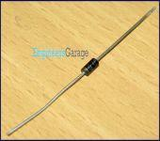

1N4001 is a member of 1N400x diodes. Diode is a rectifying device which conducts only from anode to cathode. Diode behaves open circuited for the current flow from cathode to anode. 1N4001 is a 1A diode with low forward voltage drop and high surge current capability.

**CAPACITOR ( 1000 UF ) :**

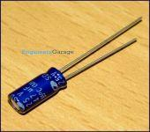

Capacitor is a passive component used to store charge. The charge (q) stored in a capacitor is the product of its capacitance (C) value and the voltage (V) applied to it. Capacitors offer infinite reactance to zero frequency so they are used for blocking DC components or bypassing the AC signals.

**POTENTIOMETER :**

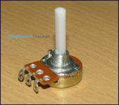

Potentiometer (Pot) is another class of variable resistors and is used as an adjustable voltage divider. It consists of a fixed resistance track having connections at both ends and a sliding contact, called wiper, which moves along this track by turning the spindle.

**BATHROOM LIGHT TIMER**

* TEAM MEMBERS NAME WITH REGISTER NUMBER
* PHOTO OF TEAM MEMBERS WITH EXPERIMENTAL KIT IN WORKING CONDITION